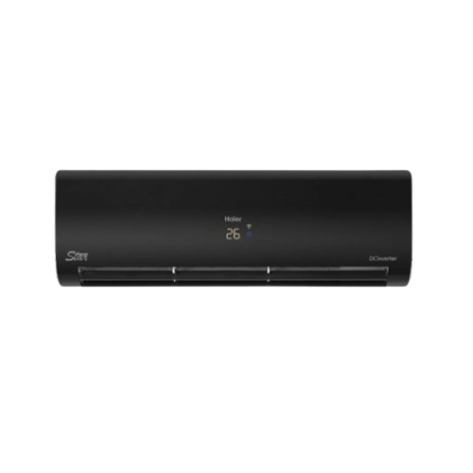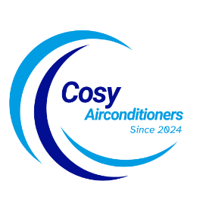

**THANK YOU!**

**Product details**

SKU: HSU-18HFCF/013USDC (W)

**Pearl Inverter**

Rs 175,999.00 Rs 160,000.00

Anti Corrosion 100%copper

Wide Voltage With Hyper PCB

Self Cleaning

With adoption of optimized cooling system, the cooling capacity of Haier Air Conditioners still could catch up 100% to provide the best cooling experience to user at 46◦C high temperature.

**WELLCOME TO OUR WEBSITE**